**TEXT ANALYTICS**

**Text Mining - ‘Mid-sized Sedans’**

**DATA SOURCE** – For this assignment, we used Edmunds.com, scraped reviews data and performed analysis on mid-sized sedans.

* **Link** - <https://forums.edmunds.com/discussion/7526/general/x/midsize-sedans-2-0>

**TASK A:**

**Identify top 10 brands by frequency. From the posts, calculate lift ratios for associations between the brands. Show the brands on a multidimensional scaling (MDS) map**

***(see attached .ipynb file for code).***

1. The Top 10 Car Brands by frequency are:

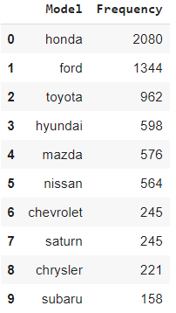

Table 1 - Top 10 Car Brands

1. Lift Values of the Top 10 car brands

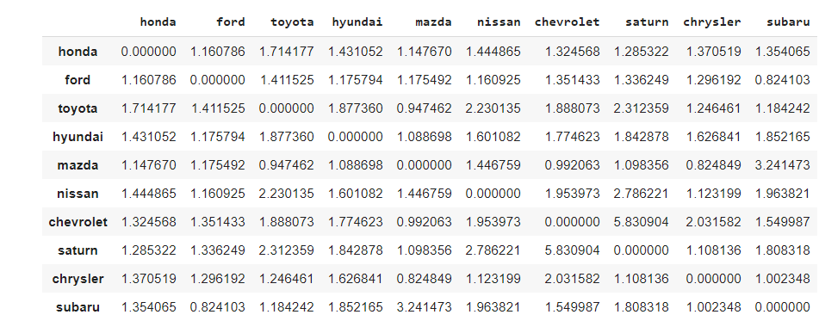

Table 2 - Lift Values of the Top 10 Car Brands

1. MDS Map of Top 10 Brands

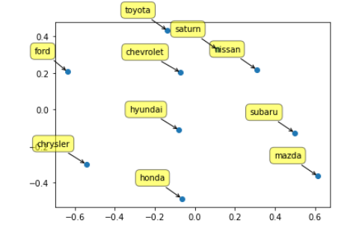

Figure 1 - MDS Map of Top 10 Car Brands

**TASK B**:

**What insights can you offer brand managers from your analysis in Task A? Choose two brands that you can offer the most interesting/useful insights for.**

The MDS plot shows that cars that are near each other are more often mentioned together than cars that are farther apart. Overall, we can identify 4 clusters (as illustrated in Figure 2 below). It is therefore important for brand managers to distinguish themselves from brands within the same cluster in order to capture a substantial market share.

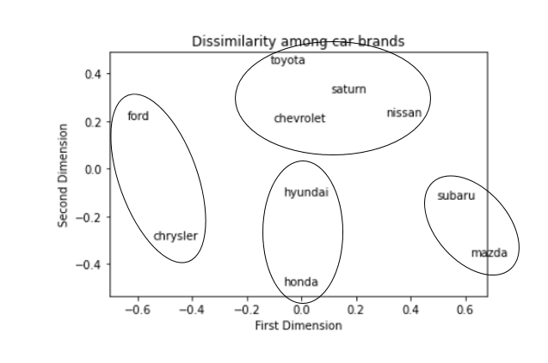

Figure 2 - Clusters of Car Brands

More specifically, we would like to highlight the co-occurrence of 2 brands: **Saturn** and **Chevrolet.** These brands are close together in the MDS plot and have a lift value of 5.807201, which is higher than any of the other brand-pairs we analyzed. It is important to note that Saturn and Chevrolet are both manufactured under the same parent company: General Motors. Both brands are considered similar in reviews, so it is important for the brand managers to have distinctive messaging and promotional strategies for each brand, so as to avoid confusion and cannibalization.

During our research and analysis, we discovered that Saturn was in fact discontinued, and in 2012 General Motors reintroduced the discontinued Saturn Vue as the 2012 Chevrolet Captiva Sport. This falls in line with our analysis. It can be hypothesized that the management team was (easily) able to reintroduce a Saturn model as a Chevrolet car because in the minds of the consumer, both brands were already similar. Had brand managers performed a similar lift analysis, perhaps they would have been able to identify this co-occurrence risk sooner and would have made better attempts to distinguish their two separate brands, and save the Saturn brand.

With a lift value of 3.241473, brand managers for Subaru and Mazda should also attempt to distance their brands from one another, to be able to capture more distinct customers.

**TASK C:**

**What are the 5 most frequently mentioned attributes of cars in the discussions?**

To get the most frequently mentioned attributes, we looked through the frequency distribution of every word used in the reviews. We then selected the most used words to describe car attributes and put them into more general attribute categories.

These attributes were made by combining these words into these categories.

* Performance -> [engine, power, hp, speed, run, transmission]
* Look -> [interior, design, sporty, pretty, quality]
* Cost -> [price, value, warranty]
* Size -> [big, small, midsize, large]
* Gas -> [mileage, mpg, fuel, mile]

The 5 most frequently mentioned attributes of cars from this forum were:

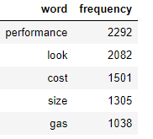

Table 2 - Top 5 Attributes

**Now pick the 5 most frequently mentioned brands. Which attributes are most strongly associated with which of these 5 brands?**

For each of our Top 5 most frequently mentioned brands, the most associated attributes were:

* + Honda - Cost
  + Ford - Look
  + Toyota - Size
  + Hyundai - Cost
  + Mazda – Size

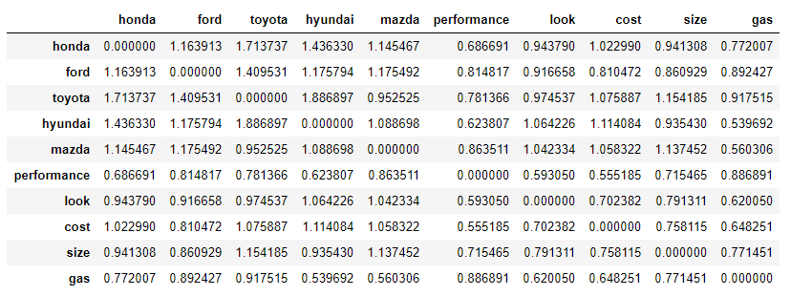

Figure 3 - Lift Values of Brands and Attributes

**TASK D:**

**What advice will you give to a (i) product manager, and (ii) marketing/advertising manager of these brands based on your analysis in Task C?**

The most significant associations between attributes and brands were the following:

High Associations:

* Toyota and size (lift = 1.154)
* Hyundai and cost (lift = 1.114)
* Mazda and size (lift = 1.137)

Low Associations:

* Toyota and performance (lift = 0.781)
* Mazda and gas (lift = 0.560)
* Hyundai and performance (lift = 0.624)

Therefore, we were able to generate the following insights for these three brands:

Insights for Hyundai:

Product Manager – Hyundai sedans are associated with cost the most (lift = 1.114), and very rarely associated with performance (lift = 0.624). Therefore, it is clear that consumers care more about cost when it comes to reviewing Hyundai than performance. So, the product manager should focus on making low-cost cars at the expense of performance as cost is much more important to Hyundai consumers.

Marketing/Advertising Manager – Ad campaigns should be more focused on cost. Another brand that is highly associated with cost is Honda, so they should convince users that their cars are less expensive than Honda sedans, which are a competitor.

Insights for Mazda:

Product Manager – Mazda cars in this category are associated the most with size (lift = 1.137), and not associated with gas (lift = 0.560). Clearly, consumers are not taking into account the gas mileage when they purchase a Mazda mid-size sedan, but rather they mostly care about the size of the car. Since our size attribute included both “big” and “small”, Mazda should conduct further analysis and look into what whether their consumers prefer larger or smaller cars and build products that fit those needs.

Marketing/Advertising Manager – Ad campaigns should stay away from trying to compare gas mileage with other brands, as Mazda customers disregard gas compared to the other attributes. However, they should boast about their optimal size for cars in this class.

Insights for Toyota:

Product Manager – Attributes dealing with size and performance are most associated with Toyota products. Therefore, we can assume that the customers who seek out Toyota cars care about size and can sacrifice performance aspects of the car.

Marketing/Advertising Manager – Mazda is a competitor when we are talking about the aspects like size and performance. Therefore, in the marketing campaigns it is important to distinguish Toyota from Mazda, as the customers who value size more and value performance less can easily switch to Mazda from Toyota.

**TASK E:**

**Which is the most aspirational brand in your data in terms of people wanting to buy or own? Describe your analysis. What are the business implications for this brand?**

We define an **aspirational brand** as a brand or product which a large segment of its exposure audience wishes to own, but for economic reasons cannot[1]. In order to find the most aspirational brand within our dataset, we:

* Scanned the frequency list of all words in the database (obtained in Task C), and identified which words related to our definition of ‘aspirational’; (buy, sale, consider, dealer, offer, buyer, great, pay, value, try, nice, dealer, deal)
* Replaced all related words with the word ‘aspirational’;
* Found the frequency of the word ‘aspirational’ in our dataset;
* Create a co-occurrence matrix between ‘aspirational’ and all cars in our dataset;
* Calculated the lift values and chose the brand with the highest lift value in relation to ‘aspirational’.

Using the above methodology, we noticed that none of the brands had a lift value above 1. However, within the dataset, **Chrysler** was the most brand that was most associated with aspirational (lift value = 0.85, as seen in Table 3 below). Given the fact that reviews in our dataset were written in 2007, our analysis is in line with Chrysler’s established brand image during that time period. Founded in 1925, Chrysler is one of the "Big Three" automobile manufacturers in the United States (along with Ford and General Motors). In earlier years, Chrysler was a premium brand and a strong competitor for luxury brands such as Cadillac and Lincoln. However, ever since the company emerged from bankruptcy in 2009, it has failed to regain its aspirational status. Once boasting a broad array of high-end products, the Chrysler brand is today a shadow of its former self, with just the Pacifica and Voyager minivans. According to a research article published in the [Harvard Business Review](https://hbr.org/2015/06/a-better-way-to-map-brand-strategy), Chrysler is now positioned as a peripheral brand, while its past competitor, Cadillac, is still seen as an aspirational brand (see Figure 4 below).

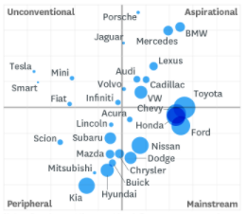

Figure 4: Brand Positioning of Different Cars

It is, therefore, crucial for Chrysler’s current management team to employ the right strategies to revive the brand’s image. An aspirational brand strategy is concerned with creating a ‘dream’ and generating positive emotional reactions from consumers. Aspirational brands often have 2 main goals: making themselves central in the minds of consumers within their category, and distinctive from the mainstream. This leads to several key business implications.

Peripheral brands have little to distinguish them. One of Chrysler’s key challenges will be not only to retain distinct identities from a design, feature, and marketing standpoint, but also to create new innovative and forward-thinking products that give them a central position in the consumer’s mind. Back in 1926, Chrysler was the first car to offer a downdraft carburetor on its models, and one of the first cars to use a rubber engine. They need to bring back this innovative spirit that helps shape the car category. Chrysler’s Product Managers should, therefore, focus on launching distinctive and innovative features to their existing product line, or launch a new luxury line if they are willing to invest in R&D. One great aspect about Chrysler mid-size cars is that they are reliable, so the product team should capitalize on this and heighten the user experience, which will increase brand strength.

Brand and advertising managers should focus on launching campaigns which highlight Chrysler’s distinctive features. It is important to note that older consumers may still consider Chryslers as an aspirational brand, while today’s younger consumers would give it a peripheral position. Therefore, it is important to target different marketing strategies and messaging to the right segments of the population. Brand managers should also capitalize on the ‘diehard’ fan following that Chrysler has, as a once-aspirational brand, by building and promoting loyalty programs and engaging more with their social media and offline followers. As one of the oldest car manufacturers, they should use Chrysler’s ‘legacy’ status to their advantage. Using the right influencers who align with an aspirational image to promote the brand will be a great marketing strategy towards the younger consumers in today’s social media world.

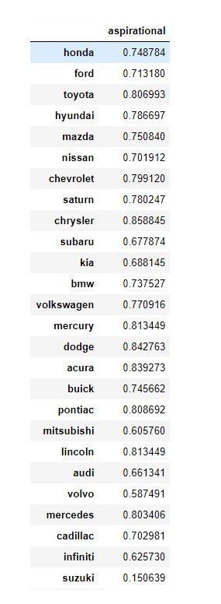

Table 3 - Lift Values of Cars and Aspirational

1. https://en.wikipedia.org/wiki/Aspirational_brand